AUTH-002
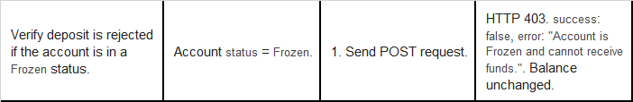
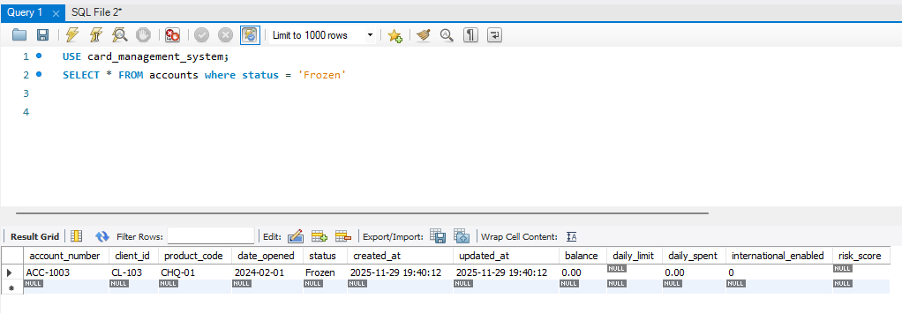
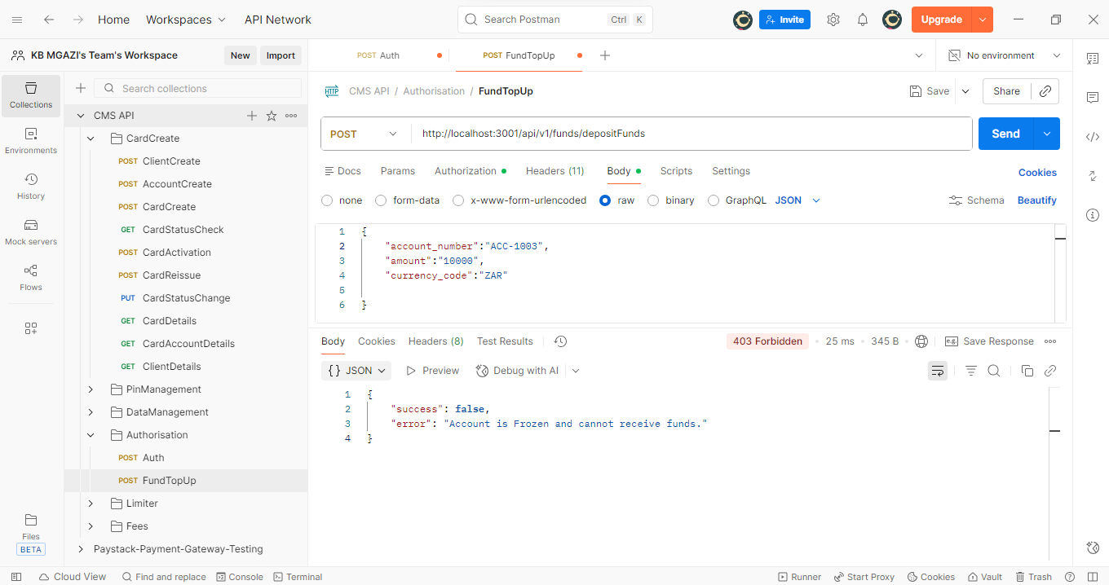
Request:
{
"account_number":"ACC-1003",
"amount":"10000",
"currency_code":"ZAR"

}
Response:
{
"success": false,
"error": "Account is Frozen and cannot receive funds."
}

